**Brooklyn torah gazette**

**For parshas vayishlach 5780**

Volume 4, Issue 13 (Whole Number 165) 16 Kislev 5780/ December 14, 2019

**Printed L’illuy nishmas Nechama bas R’ Noach, a”h**

For a free subscription, please forward your request to [***keren18@juno.com***](mailto:keren18@juno.com)

*Reprinted from the November 22, 2019 edition of the Flatbush Jewish Journal.*

**Rabbi Berel Wein Offers a**

**Historical Analysis of the**

**Jewish Diaspora Experience**

**By Daniel Keren**

(“A Historical Journey Through the Countries of Our Diaspora: In the Footsteps of Eliyahu Hanavi by Berel Wein, 2019, Shaar Press, 342 pages)

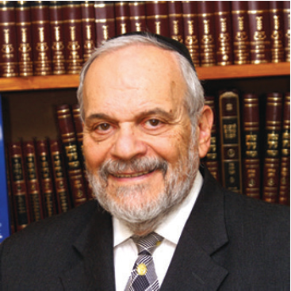

Rabbi Berel Wein has once again come out with a popular narrative of Jewish history that deserves to be in every Jewish home and library. “In the Footsteps of Eliyahu Hanavi: A Historical Journey Through the Countries of our Diaspora” follows the publication of his classic Trilogy (“Echoes of Glory, “Herald of Destiny” and “Triumph of Survival”) and study of 20th Century Jewish life (“Faith & Fate.”

**Giving Up a Challenging Career as a Lawyer**

A pulpit rabbi who gave up a challenging career as a lawyer in his hometown of Chicago to serve congregations in Miami Beach, Rockland County and now Jerusalem, while giving countless shiurim on the Talmud and Jewish history, Rabbi Wein developed a unique talent to communicate the richness of the Jewish story both as a writer (today he is a columnist for the Jerusalem Post) and a popular speaker. In recent years he has led many informative tours to historic Jewish sites of our Diaspora.

In his introduction, Rabbi Berel explain the origins for this his latest book on Jewish history:

“The concept for this book occurred to me while sitting at the Passover Seder in the eighty-third year of the life granted to me by my Creator. By tradition and legend, the prophet Eliyahu [Elijah] visits every Passover Seder, in every location and era.

**Guests Rose in the Traditional Welcome to Eliyahu**

“As all of our guests rose in the traditional welcome to Eliyahu, I thought: ‘Would it not be a great experience to accompany the prophet on his epic journey?’

He has visited the communities and scattered remnants of Israel during the millennia of our exile and Diaspora. He has witnessed the panorama of Jewish history, and he has a unique overview of the events and personalities that have shaped that history.

“The story of the Jewish people and their tenacious survival against all odds and despite powerful foes is the stuff of prophetic legend. But the facts are present and the story is true in all of its miraculous glory and tragedy. So I decided that I would write this book, tracing and reviewing the journeys and events that created the great story of Diaspora Jewry: a story of hope and survival, of loyalty and moral purpose.”

And for that decision made by one of the premiere Jewish teachers of our age made four years ago, readers in the English-speaking community around the globe owe a great debt of gratitude to not only Rabbi Wein but also to Shaar Press, a division of ArtScroll/Mesorah Publications and all those individuals who assisted Rabbi Wein by gathering photos of Jewish life, synagogues and important historical and cultural documents from around the world to accompany his text.

“In the Footsteps of Eliyahu Hanavi” is a beautiful coffee table book that you won’t want to lend to somebody outside your house. So I guess in order to fulfill the mitzvah of v’ahavta l’reacha kimocha (love another Jew like yourself,) you might consider giving this easy-to-read and enjoyable book as a gift for others. Indeed, I got my copy by hinting strongly to my children that it would be a most appreciated birthday present.

**A Brief Outline of the History of the Jewish Diaspora**

The author has endeavored to portray a brief outline of the history of the Jewish Diaspora in both chronological and geographical format, beginning with Mesopotamia where our forefathers (Avraham, Sarah, Rivka, Rochel and Leah) originated before coming to Eretz Yisroel.

Rabbi Wein is nothing if not comprehensive and he has divided his interesting challenge of following in the footsteps of Elijah the Prophet into 21 chapters beginning with the Middle East and North Africa before jumping into Europe and then crossing the Atlantic to visit the United States and Canada; before diverting south to Central and South America and Mexico; then jumping back across the Atlantic to South Africa before taking a spiritual Supersonic airplane to the Far East, India, China, Japan and finally Australia and New Zealand.

**A Combination of Honesty and Compassion**

**For the Challenges of Jews Over the Millennia**

The author tells the fascinating story of the Jewish experience with a combination of honesty and compassion for the challenges of Jews over the millennia, many for which we today in the comfort of America must thank G-d every day that we never had to endure and perhaps that will also give us to courage to withstand the temptations of assimilation that is our great threat today.

In reading Rabbi Wein’s interesting account of the Jewish challenge of being a light unto the nations, we can only hope that we gain inspiration from “In the Footsteps of Eliyahu Hanavi” to dedicate ourselves to improving our lives spiritually so we can read the final chapter in this saga with the coming of Moshiach and the long-awaited geula (redemption) of the Jewish people culminating with our return to our Promised homeland in Eretz Yisroel (the Land of Israel) and the restoration of our holy Beis Hamikdosh (Temple) in Yerushalayim.

If you can’t persuade your children or spouse to buy you a copy of “In the Footsteps of Eliyahu Hanavi: A Historical Journey Through the Countries of our Diaspore” you can go to any Jewish bookstore or contact any number of online options by googling the book title and author name.

*Reprinted from this week’s edition of The Jewish Connection.*

**As Rockets Rain Down on Our Brothers and Sisters in Eretz Yisroel (Part 2)**

**By** [**Rabbi Moshe Meir Weiss**](https://www.jewishpress.com/author/rabbi-moshe-meir-weiss/)

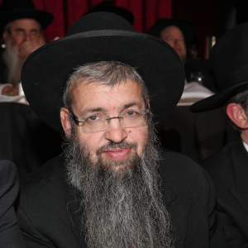

Last week, we started reflecting upon the frightening barrage of rockets that our brethren in Eretz Yisroel are being assaulted with. Jews all over the world look in amazement at the reaction of the global community. Their silence is deafening. Would any other country tolerate even one missile being launched at their homeland?

Many just shake their heads in disbelief and wonder why the world isn’t showing outrage at such vile behavior. The more knowledgeable observer says sagely this is just proof of what the Navi says that we are a “Seh bein shivim zea’vim – We are like a sheep surrounded by 70 wolves.”

Others elaborate further that it’s no surprise for we are taught, “Halacha b’yadua she’Eisav soneh es Yaakov – It is an immutable way of the world that Eisav hates Yaakov.”

**Another Dynamic at Play**

While this is true, there is another dynamic at play. The Gemora in Masechtas Megillah wonders why Esther invited Haman to a private feast. How was she able to sit at a private meal with such a monster?

The Gemora offers many explanations. One of them is that Esther wanted to ensure that the B’nei Yisroel not relax and say “We have nothing to worry about because, “Achos yeish lanu b’beis ha’melech – We have a sister in the palace.” We have an ace up our sleeve. We don’t have to get too worried.

Esther didn’t want them to put their faith in her, but rather in Hashem above. Similarly, if America, Great Britain, and Canada would be up in arms and would threaten the Arabs, we wouldn’t be running for our Tehillims and our Siddurim. Hashem wants us to remember, “Ein lonu l’hisha’ein elah al Avinu she’baShamayim – We don’t have anybody to rely on except our Father in Heaven.”

**A Rocket Landed Right in**

**The Middle of a Busy Highway**

There is another aspect about the rocket attacks that I want to point out. There was a rocket that landed right in the middle of a busy highway. A motorcyclist took a video of it and I saw the video. The highway was as busy as the Belt Parkway during rush hour. The rocket landed smack in the middle.

If it had hit a moving car, it would certainly have killed the occupants and likely caused a fatal pileup. However, there was one lone dumpster by the divider of the highway and the rocket hit that dumpster and nothing else. When we see this, we must know that our collective prayers and Torah study are at work in successfully shielding our brothers and sisters.

Then there is our other secret weapon and that is our Gedolei Yisroel, our great Tzadikkim. When Moshe Rabbeinu sent the spies to check out Eretz Yisroel, he asked them to see if ha’yeish bah eitz im ayin, if there is a tree or not. That seems to be a very queer instruction. He wanted to see if there was a lone tree in Canaan?

**The Explanation from Rashi**

Rashi explains that he was telling them to search whether there a righteous person living among the seven nations, like a stout tree, who would protect them – as we find that Mesushelach protected his entire generation from the flood until he died.

It is said that the Chazon Ish, zt”l, zy”a, said that he was unaware of the holocaust for if he had been aware he would not have let it happen (through his prayers). This is why in the blessing of Al HaTzadikkim we pray that Hashem should show mercy to our righteous ones because we realize that the continued existence of such giants like Rav Chaim Kanievsky, shlit”a, ensures the safety of the entire land.

One more thing. Hashem gave us the great gift of the Iron Dome and the brave soldiers that man it. The iron dome has protected us mightily. Any one of the rockets it intercepted could have landed on a hospital, school or apartment complex.

The iron dome gives us something definitive to pray for as Elisha asked the woman who asked him for help with sustenance, “Do you have anything is the house.” She answered him that she had oil. He told her to get many vessels and keep on pouring the oil, but she needed a little oil for the blessing to devolve upon. So too, we keep crumbs on the table when we bentch so that our requests for parnasah should have something to devolve upon. The Iron Dome give us something concrete to pray: That it shouldn’t miss its mark and always be accurate.



*Photo of the Iron Dome in Israel releasing a missile to blow up a deadly rocket fired by our Arab enemies who want to harm our brethren in Eretz Yisroel.*

In the merit of our prayers, may there be serenity in Eretz Yisroel, tranquility for Jews all over the globe, and we should be blessed with long life good health and everything wonderful.

*Reprinted from the Parshas Chayei Vayeitzei 5780 email of The Jewish Vues.*

**Rav Avigdor Miller on**

**Love at First Sight**

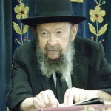

**QUESTION: Is it true that when the right one comes along it will be love at first sight?**

**ANSWER:** It’s definitely not true. You have to know that Hakodosh Boruch Hu has prepared wrong ones too. And many times the wrong one comes along first. So you have to make sure it will be love at first sight and second sight and third sight.

And the truth is that it shouldn’t be your sight you’re relying on. The best way to look at your future kallah is through the eyes of your mother or your aunt. As your aunt looks at the kallah, she sees her. You don’t see her: you see her hair, all puffed up. But your mother and your aunt see the kallah. And that’s very important.

And that’s why in the olden days the women used to make the *shidduchim*. They knew this and this girl; that’s the right one. They knew her character. But the boy doesn’t know anything about her character. He just sees a nose, he sees the painted eyelashes, he sees the paint on the lips, and he is captured! And therefore, the first time is meaningless.

*Reprinted from the December 1, 2019 email of Toras Avigdor adapted from Tape #609.*

**Why G-d Allows Idols to Exist**

**From the Talks of the Lubavitcher Rebbe**

**Rabbi Menachem Mendel Schneerson, Zt”l**

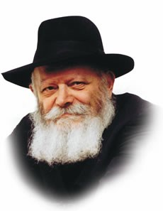

This week's Torah portion, Vayishlach, contains the episode of Dina's violation by Shechem, and her brothers' vindication of the crime. Finding idols among the spoils his sons had taken, Yaakov (Jacob) instructed them, "Put away the strange gods that are among you, and cleanse yourselves."

Maimonides cites this verse to support the ruling that the worship of idols renders a person spiritually unclean and impure.

The fact that Maimonides brings this verse as proof is unusual, for he rarely cites a textual basis in his writings.

Interesting, too, is the fact that the Talmud cites totally different verses to support the Jewish law that idolatry causes spiritual defilement, whereas Maimonides quotes a little-known Midrash. We must therefore conclude that Maimonides' intent was to teach us something else about the nature of idolatry and its consequences.

The very existence of idolatry raises certain fundamental questions.

How can an entity even exist whose sole purpose is to conceal the Oneness and Unity of G-d and His dominion over creation?

This very question was asked by the ancient King Ptolemy of the seventy Sages whom he forced to translate the Torah into Greek.

Their answer was that G-d is in no way required to destroy His world just because some foolish people choose to worship the sun and the moon.

And yet, one may still wonder why the world was created in such a way as to leave room for people to worship false gods. Why didn't G-d make His presence and rulership over the world more obvious, so that no one would ever be led astray and the futility of idol worship would be immediately apparent?

The answer lies in the above verse itself: "Put away the strange gods that are among you."

The existence of paganism was allowed by G-d solely for the purpose of it being rejected and refuted. G-d wants the Jewish people to actively fight the notion that any power can exist aside from Him, and to constantly demonstrate His Oneness.

The prohibition against idolatry is different from all other prohibitions in the Torah, for it proscribes something which does not really exist; laws such as those against eating non-kosher food or possessing leaven on Passover deal with actual entities that the Torah forbids us to eat or derive pleasure from.

Idol worship, however, is only an illusion, for in reality, nothing can exert any influence over creation aside from the Creator Himself.

G-d's desire is that man, through his service, uncover this truth and come to the realization that idolatry is false.

On a deeper level, not only does idolatry have no independent existence, but neither can any entity outside of G-d; the entire world is but a part of G-d's Unity. The Divine mission of the Jew is to reveal this underlying reality through the medium of Torah and mitzvot.

This realization should give us much encouragement in life, for no matter how many obstacles we may encounter in our service of G-d, we must always bear in mind that they are just as illusory as the worship of idols; G-d is the only reality that truly exists.

All we need do is "put away the strange gods" that are among us and the truth will be revealed.

*Reprinted from the Issue #343 of L’Chaim Weekly (Parashat Vayishlach 5755/1994)*

**Rabbi Berel Wein**

**On Vayishlach**

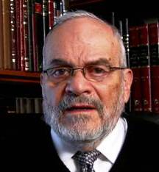

Our father Jacob and his family face two great crises that are recorded for us in this week’s Torah reading. The first is the long-awaited encounter with his jealous and dangerous brother, who decades later still smarts over the deal that he made in selling his birthright to Jacob.

Jacob is aware that his brother has the potential to destroy him and his family, and he prepares three different avenues of salvation – a financial settlement, the invocation of heavenly protection through prayer, and finally, the preparation of physical means of self-defense.

**Jacob’s Brother Accepts the Financial Gifts**

In the end, his brother accepts the financial gifts offered him and departs, never again to really become part of Jacob’s family and destiny. Jacob does not escape unscathed from this encounter, for he is crippled by the heavenly representative of his brother who wrestles with him to a draw. Yet Jacob feels himself relieved that, at least temporarily, his brother is no longer a mortal threat.

Throughout the ages, the Jewish people have always attempted to mollify their enemies with financial gifts and contributions to the general non-Jewish society. This has always proven to provide a temporary stay of violence with little long-lasting consequences.

The Jewish people relied on praying to heaven for protection as their sole avenue of escape from destruction. They were in no position to physically defend themselves from crusades and pogroms. This pattern in Jewish history has repeated itself over and over until our very day.

**The Kidnapping and Rape of Dina**

The second incident of violence against the family of Jacob is recorded for us in the story of the kidnapping and rape of Dina. Here Jacob unaccountably appears to us as being passive and having no real plan for Dina’s salvation and for punishing the evildoers.

It will be Shimon and Levi that will respond violently and save Dina from her captors, showing that violence, even justified violence, always comes with its own costs. It is interesting to note that the Torah does not record for us any appeal from Jacob to Heaven. He apparently accepted that this tragedy occurred to him and his daughter somehow justifiably, and that there was no necessity for an appeal to Heaven after the fact.

**The Judgement of Heaven is**

**Always Inscrutibe to Human**

Jacob is aware that the judgement of heaven is always inscrutable to humans as the Talmud itself states: those matters that Heaven has hidden from our understanding, humans should not attempt to understand.”

Jacob will later criticize Shimon and Levi for their behavior and their actions. Yet, the Torah itself leaves the correctness of the behavior of Shimon and Levi without judgement and throughout the ages, the commentators have debated the matter of contention between the father and the sons.

Suffice it to say, that Shimon, as the teachers of Israel, and Levi, as the priests of Israel, remain heroic figures in Jewish history and current Jewish life. In our time, through the independent might of the state of Israel, these three avenues of salvation that Jacob had in the encounter with his brother, once again exist in terms of Jewish survival and success. They should be employed very judiciously.

*Reprinted from this week’s website of Rabbiwein.co*

**Rabbi Eli J. Mansour On**

**Parashat Vayishlach**

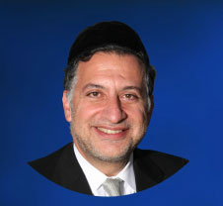

In Parasat VaYishlach, perek 33, pasuk 17, the Torah tells us that Yaakov Aveenu built himself a house and he built for his cattle Succot (huts.) In fact, Yaakov Aveenu called that location Succot based on the huts he built for his cattle. So the Or HaChayim HaKadosh asks what is the significance of Yaakov’s construction of huts for the cattle, and why did he name the city after them?

The Or HaChayim HaKadosh writes that Yaakov was probably the first person to show such mercy to animals. Yaakov Aveenu went out of his way to build these huts and show to the people his special compassion he had for these animals. Yaakov Aveenu was teaching a very important lesson.

Yaakov Aveenu made a living from these animals, and the construction of these huts was an expression of respect and gratitude to them. These animals provided him with parnasa (livelihood), and for that Yaakov was grateful and appreciative. So Yaakov in his actions is coming to teach us that we need to be thankful to the ones providing us with a livelihood.

Based on this we can understand a pasuk later on in the Torah in Parashat VaYeshev when Yaakov tells his son Yoseph to go to Shechem and check on his brothers and on the sheep. Typically one would not understand Yaakov’s meaning or intent when he told Yoseph to check on the sheep.

But based on the lesson above, we can now understand that Yaakov Aveenu was showing concern for the animals that were providing them with a livelihood. He wanted Yoseph to make sure that the needs of the animals were being tended to. So again, we see Yaakov’s commitment to appreciation of those who provided him with a livelihood.

There is another episode in the end of Parashat Miketz that further teaches us about respecting our source of livelihood. Yoseph was being seduced by Potifar who was the wife of his employer. She tried again and again, but Yoseph did not succumb to it.

Chachamim tell us that he gained the strength needed to fight the temptation and lure from the image of his father Yaakov. He remembered the lessons his father Yaakov taught him. Yaakov cared for his animals for they provided him with a livelihood. Yaakov built them huts and he had instructed Yoseph to see to their needs in Shechem.

So Yoseph understood the importance of caring for the source of one’s livelihood. And Yoseph was therefore able to refrain from giving into temptation for he was grateful to Potifar, and would not disrespect Potifar by yielding to his wife.

The lesson we learn here is very significant. Yaakov Aveenu showed gratitude to his animals, so therefore we all the more so must show gratitude to those people who provide us with our livelihood. We see too many people complaining and expressing disrespect towards their employers. We must learn from the lessons of Yaakov. An employee must be grateful to his employer for providing him with a job and a pay check.

*Reprinted from this week’s website of the Edmond J Safra Synagogue of Brooklyn website.*

***Thought for the Parsha***

*"I have sojourned with Lavan... and I have an ox, a donkey, flocks, servants and maids..."(*Gen. 32:4,5)

In order to frighten Esav, Yaakov told him that he had "an ox and a donkey."

Why would Esav be afraid of a donkey?

Yaakov was referring to the donkey upon which Moshiach will ride.

Moshiach will ride on a donkey because of his humility. He will also overcome all the nations of the world in a quiet way, without war, just as Yaakov overcame Esav. *(Breishit Rabah)*

*Reprinted from the Issue #343 of L’Chaim Weekly (Parashat Vayishlach 5755/1994)*

**The Shmuz onParshas Vayishlach**

# **Going Home- The**

# **Merit of Eretz Yisroel**

**By Rabbi Bentzion Shafier**

**Founder of TheShmuz.com**

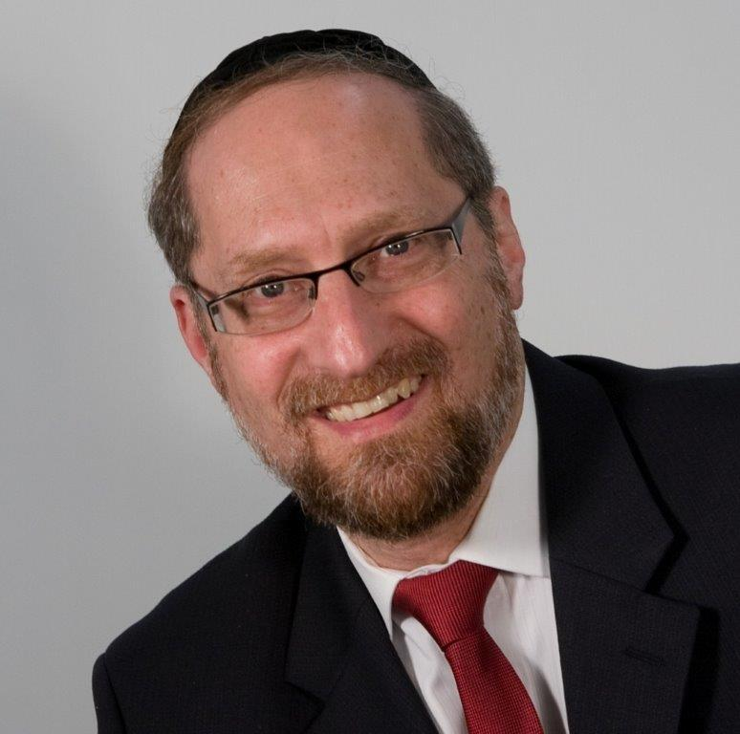

“*And Yaakov became very frightened, and it caused him much pain, and he split the nation that was with him, as well as the sheep, the cattle and the camels, into two camps*.” – Bereishis 32:7

Yaakov Avinu received word that his “brother” Aysav was coming to greet him. He understood fully well that this was not to be a warm family reunion. Aysav came accompanied by a band of four hundred armed men, bent on revenge. The Torah describes that Yaakov was “very frightened,” so he prepared for war.

The Rishonim are bothered by why Yaakov would fear Aysav. After all, HASHEM had promised to return him to his father’s house in peace. Throughout the many years, HASHEM was right there protecting him, guarding him, keeping the promise. Why should he now fear a mere mortal?

The Dos Zakainim answers that Yaakov was afraid of the “zchus of Eretz Yisrael.” For the past twenty years, Aysav had been living in Eretz Yisrael while Yaakov had not. Therefore, Yaakov was afraid that if he engaged in mortal combat with Aysav, that merit might win the day for him, and Yaakov might die in battle.

This Dos Zakainim is difficult to understand on a number of levels. First, the reason that Yaakov wasn’t in Eretz Yisroel was not that he had abandoned the land, but because he fled from Aysav. He spent the first fourteen years in the yeshiva of Shem, and then he worked for Lavan.

But even more pointedly, what possible merit could Aysav have from living in Eretz Yisrael? He wasn’t practicing Torah and mitzvos. Quite the opposite, he was a rasha. His entire existence was focused against holiness. Eretz Yisroel is a land that has an enormous amount of kedusha and cannot tolerate wickedness; it is highly sensitive to tumah.

Aysav’s very presence in the land should have been intolerable. The land should have desired to throw him out. So what type of merit would he have from being in that land? It would seem the opposite. His many years of **defiling** that holy land should work against him, not for him.

The answer to this question can best be understood with a perspective on capitalism.

**The contribution of the private sector**

If a man owns a successful small business, he might do a million dollars a year in sales. But that is the gross revenue, not the amount he takes home. As a rule in business, 15% of revenues is a reasonable profit margin. So, if his mark-ups are strong and his expenses are in line, he might bring in a net profit of $150,000. 85% of the monies that he earns go to expenses.

And this illustrates an interesting phenomenon. While his only motivation may have been to earn a living for himself, he is providing a substantial gain to those he does business with. In this scenario, $850,000 of his efforts are going to vendors, suppliers, and employees. And while it may not at all be his intention, he is making a substantial contribution to the economy as a whole.

In the same sense, Aysav was engaged in the building of Eretz Yisroel. While his interests may have been strictly his own, he maintained sheep, owned fields, hired workmen and built fences. His efforts directly benefited the land. It was cultivated and improved because of him.

And this was Eretz Yisroel, the land that HASHEM chose as the site for the Jewish people to settle, the home of the eventual Bais HaMikdash. It’s very ground is holy. While he may not have been a credit to the land, and may not even have felt an attachment to it, because of him, the land was built up – and that is a great merit.

Yaakov did not in any sense think that Aysav had more merit than he did as a person. He was well aware of the different lives they led. But Yaakov understood that Aysav had a tremendous zchus: he was responsible for building the land, and because of this Yaakov was afraid. In “times of danger,” a particular merit can stand up for a person, and that can change the outcome of a confrontation.

**We don’t belong here**

This concept is very relevant in our lives. While we patiently wait for the imminent coming of Moshiach, one of the concepts that must be in the forefront of our minds is that we are in a foreign country. We don’t belong in chutz l’aaretz. It isn’t our home. While the United States is one of the most benevolent lands that has ever offered us residence, a Jew doesn’t belong in Brooklyn. When we build up this land, whether with palaces or impressive businesses, we are building other people’s land. We get back nothing for it.

A Jew belongs in his homeland, in Eretz Yisroel. HASHEM invested very different properties into the land of Israel. The air there makes one wise. It is a land steeped in holiness, and when a Jew lives there, it is much easier to experience HASHEM, much easier to reach perfection.

We see from this Chazal another advantage of living there. By his very presence, a Jew has the merit of cultivating the holy land. When he rides the buses and frequents the shops, he is supporting the local economy. When he operates a business there, he isn’t only getting back the 15% of net profit, he is benefiting many others, and his $850,000 goes towards building up the infrastructure, giving jobs to others — he is part of the building process. Because it is the holy land, the mundane becomes sacred, and he is given reward because he is a builder of our sanctified land.

While each individual and family must consult Torah guidance to determine whether living in Israel right now is best for them, one fact is clear: we belong there; it is our home. May HASHEM quickly bring Moshiach, and may we all celebrate a new dawn in our most precious homeland.

*Reprinted from this week’s website on TheShmuz.com This is an excerpt from the [Shmuz on the Parsha book](https://theshmuz.com/product/shmuz-on-the-parsha-book/).*

**YIZKOR**

**May the L-rd Remember...**

**By Margy Ruth Davis**

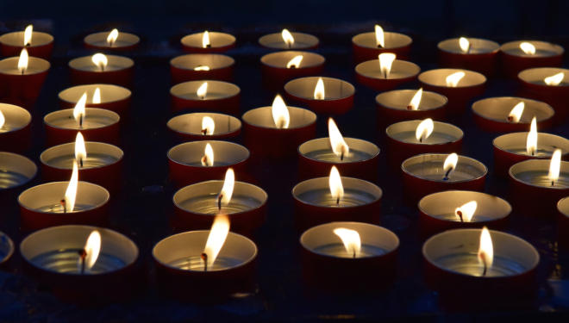

Yizkor is the prayer we say for the souls of our departed. It is a prayer based on remembrance and on memory. We remember our parents, siblings and other beloved who have left this world. We ask the Almighty to remember them, as well, as we will be giving tzedakah in their memory.

The charity we promise to give is at the crux of the Yizkor service. Judaism believes in the immortality of the soul. Although the departed can no longer perform good deeds, their souls can be elevated through our prayers and our charity.

Yizkor is recited four times each year – on Yom Kippur, Shmini Atzeret, the last day of Passover and the second day of Shavuot. Its origins can be found in the Midrash Tanhuma that quotes a verse in Deuteronomy (21:8): “Atone for Your people, Israel, whom You have redeemed.”

The Midrash tells us that the first half of the verse refers to the living; the latter half, to the dead. How are the dead redeemed? The Midrash explains: “… when we distribute charity for their sake, we take them out and bring them up like an arrow from the bow.”

Most of our liturgy is communal. We use the plural. In daily prayers, we speak collectively of our devotion and we ask — as a community — for the fulfillment of our needs.

Yizkor, however, is deeply personal. We stand alone and reflect on the lives that were taken from us, sometimes in ripe age and sometimes much too soon. While Yizkor is only one section of the memorial service, it gives its name to the whole.

The memorial has four parts. We begin with verses, recited aloud, that remind us how life is fleeting. “Man is like a breath; his days are like a passing shadow.”

Many prayer books include Psalm 91, a meditation on G-d’s care for humankind. “You will be protected beneath His wings.” We then pray Yizkor silently. We recite separate paragraphs for each of our own loved ones. We include their names and offer to give charity on their behalf.

Yizkor is followed by Kail Male Rachamim, L-rd Full of Mercy. This is the prayer that is recited at funerals in a haunting, unforgettable melody. In our silent meditations, we again include separate paragraphs for each deceased family member. The cantor may sing the Kail Male aloud in memory of the Holocaust’s six million, soldiers who have fallen in Israel’s defense and members of the congregation.

The words of Kail Male Rachamim follow closely those of Yizkor. The memorial ends with Av Harachamim, a eulogy written originally for communities destroyed during the Crusades in the 11th century. Tragically, Jewish history has expanded the roll of martyrs, now all included in this prayer.

Recited on most Shabbat mornings, it asks, “May He recall with compassion, the devout, the upright and the perfect ones; the holy ones who gave their lives for the sanctification of [G-d’s] name.”

Many people make a special effort to attend synagogue services when Yizkor is said. Yet the prayer does not require a quorum and may be said at home. There is a custom to leave the service if one’s parents are still alive. Because Yizkor can be too difficult to face, some do not recite Yizkor in the first year after the death.

Yizkor is a moment of profound connection. It binds the living and the dead. We pray silently and alone, yet alongside other mourners. We remember – and we ask G-d to remember. As Yizkor connects us with our past, the charity we pledge to give is our promise to the future. It is a small prayer that carries the entire weight of Jewish history and the belief in our ultimate redemption.

*Reprinted from the Elul 5779 edition of The Hebrew Free Burial Association Chesed newsletter.*